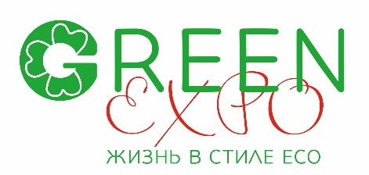
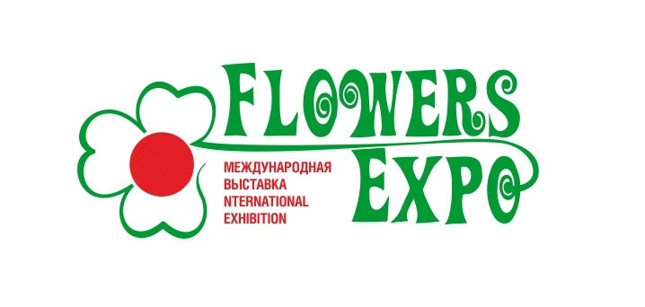
XV International exhibition «FlowersExpo 2025»
Exhibition and Forum "Green Expo. Life in Eco Style"
Moscow, International exhibition center «Crocus Expo»
Pavilion 1, halls 1,3,4 8 -10 September 2025

International exhibition on floriculture, landscaping, garden industry
and floristic “FlowersExpo’2025”
08 – 10 September 2025, Moscow, “Crocus Expo”

Competition “The Best Quality of Products”

The Competition is organized within the frameworks of the international exhibition “FlowersExpo’2025” in order to promote development of the flower market, to improve the product quality, to stimulate producers to grow high quality products using the newest varieties and technology.

1. Main Objectives of the Competition:
- Promotion of innovative development of floriculture and landscaping of Russia, rapid introduction of the latest technologies, cultures and varieties, species and breeds, ensuring consistently high quality of products.

2. Organizers of the Competition:
Organizing Committee of the International exhibition “FlowersExpo”.

3. Participants of the Competition:
Russian and international production companies, plantations, nurseries engaged in growing of flowers and ornamental cultures, trees and shrubs.

4. Conditions of Participation:
Only flowers and ornamental products displayed at exhibition stands can be put up for the competition “The Best quality of Products”.

5. Dates and Venue.
6.1. Work of the Jury starts at 10 a.m., September 8, 2025
The Competition is held one day on September 8, 2025, during the exhibition period.
6.2. Summing up the results of the Competition and awards ceremony are held during the exhibition period.
6.3. Competition venue: “Crocus Expo”, Moscow.

6. Application Deadlines.
7.1. Participants shall submit Applications in the prescribed form no later than 20 August 2025 in typing version, not by hands.
7.2. Stand number, botanical name of the variety or species (in Latin), name of the material or equipment with quality characteristics shall be specified in the Application.
7.3. The following products are presented for the Jury:
- Cut flowers – 20 - 30 pcs.
- Pot plants – 2 - 5 pcs.
- Flowers and ornamental products, trees and shrubs of the declared species or variety will be evaluated at the stand of exhibitor.
- Large size plants, shaped plants, Bonsai will be evaluated at the stand of exhibitor.

7. Competition and Evaluation Procedures.
7.1. To ensure the work of the Jury every declared plant species or variety must bear at the stand a label with its name matching the name specified in the Application.
7.2. Each variety sample receives a serial number.
7.3. Evaluation is carried out on a 10-point scale. Evaluation criteria: conformity to the declared variety, decorative value, plant’s quality (development and condition of flowers and flower clusters, cleanness of stems, floriferous shoots and leaves).
7.4. Members of the Jury carry out evaluations using individual forms from 10 a.m., September 10.
7.5. Evaluation is carried out in accordance with cultures and variety groups. Variety sample received the largest number of points is recognized “The best of the best” in its variety group.

8. Competition Jury.
8.1. The Jury includes leading specialists and experts of the sector.
8.2. Organizations whose representatives are Jury members have no right to take part in the Competitions.

9. Competition Awards:
Diplomas and medals of the Exhibition

10. Summing up the Results of the Competition and Awards Ceremony.
10.1. Summing up the results of the Competition and presentation of awards will take place during the exhibition period.

11. Information Support.
11.1. Competition results will be published in specialized magazines, after exhibition press releases, in the exhibition electronic newspaper and on the exhibition site:
www.flowers-expo.ru
The Competitions will be covered in specialized mass media.

Organizing Committee of “FlowersExpo” exhibition

