
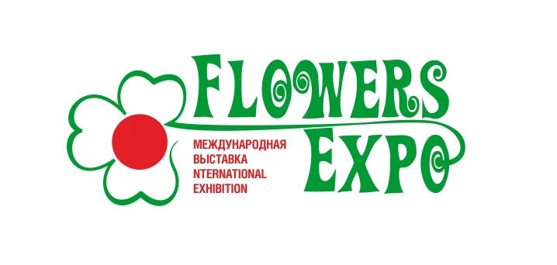
XV International exhibition «FlowersExpo 2025»
Exhibition and Forum "Green Expo. Life in Eco Style"
Moscow, International exhibition center «Crocus Expo»
Pavilion 1, halls 1,3,4 8 -10 September 2025

Competition “Novelty of the Year”

The Competition is organized within the frameworks of the international exhibition “FlowersExpo’2025” to promote rapid introduction into production of:
- New cultures and varieties of flowers and ornamental plants
- Species and breeds of trees and shrubs
- Innovative fertilizers, grounds, plant protection means
- New material and equipment for gardening and floristics.

1. Main Objectives of the Competition:
- Promotion of innovative development of floriculture and landscaping of Russia, rapid introduction of the latest cultures and varieties, species and breeds, fertilizers, grounds, plant protection means, materials and equipment for horticulture and floristic.

2. Organizers of the Competition:
International Exhibition Center “Crocus Expo”
“Exhibition Company “GreenExpo” Ltd.

3. Participants of the Competition:
Russian and international breeders and breeding companies engaged in selection of flowers and ornamental cultures, developers and producers of floricultural and ornamental products, technological materials for plants growing, new kinds of materials and equipment for gardening, accessories for floristic.

4. Participation Conditions
Only exhibits displayed at international shows for the first time are put up for “Novelty of the Year” competition in the following categories:
- Flowers and ornamental plants
- Materials, equipment for ornamental gardening.

5. Exhibition participants apply for participation in the competition in the following categories:
- Breeding flowers and ornamental cultures
- Development of new kinds of technological materials and equipment
- Introduction into production

6. Dates and Venue.
6.1. Work of the Jury starts at 10 a.m., September 8, 2025.
The Competition is held only one day on September 8, 2025, during the exhibition period.
6.2. Summing up, the results of the Competition and awards ceremony are held during the exhibition period.
6.3. Competition venue: “Crocus Expo”, Moscow.

7. Application Deadlines.
7.1. Participants shall submit Applications in the prescribed form no later than 20 August 2025 in typing version, not by hands.
7.2. Merits of the exhibit, botanical name of the variety or species (in Latin), name of the material or equipment with quality characteristics shall be specified in the Application.
7.3. The following products are presented for assessment:
- Cut flowers – no less than 10-30 ps.
- Pot plants – no less than 1- 2 ps.
- Flowers and ornamental products of the declared species or variety will be evaluated at the exhibitors’ stand.
- Non-vegetable products – exhibition sample will be evaluated at the exhibitors stand.
Information needed for assessment: price, economic feasibility, rationalization effect, positive impact on the environment, etc.
Conclusions and comments on the product.

8. Competition and Assessment Procedures.
8.1. Each declared plant species or variety is displayed on a special stand “Novelties” with a name matching the one specified in the Application no later than August 20, 2025.
Each exhibit receives its original number. The contact person – Elena Zarubina ez@flowers-expo.ru (booth N A-500).
8.2. Assessment of exhibits is carried out on a 10-point scale. Assessment criteria: decorative value, eco-friendliness, ease of use.
8.3. Members of the Jury carry out assessments using individual forms from 10 a.m., September 8, 2025.
8.4. The Jury declares assessments which are then put on the stand.
8.5. Exhibits participating in the Competition remain on the “Novelties” stand until the exhibition closure.

9. Competition Jury.
9.1. The Jury includes leading specialists and experts of the sector.
9.2. Organizations whose representatives are Jury members have no right to take part in the Competitions.

10. Competition Awards:
Diplomas and medals of the Exhibition

11. Summing up the Results of the Competition and Awards Ceremony.
11.1. Summing up the results of the Competition and presentation of awards will take place during the exhibition period.

12. Information Support.
Competition results will be published in specialized magazines, after exhibition press releases, in the exhibition electronic newspaper and on the exhibition site:
www.flowers-expo.ru
The Competitions will be covered in specialized mass media.

Organizing Committee of “FlowersExpo” exhibition

