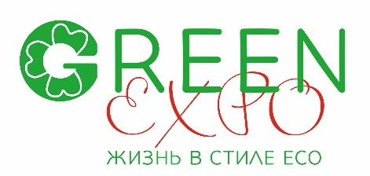
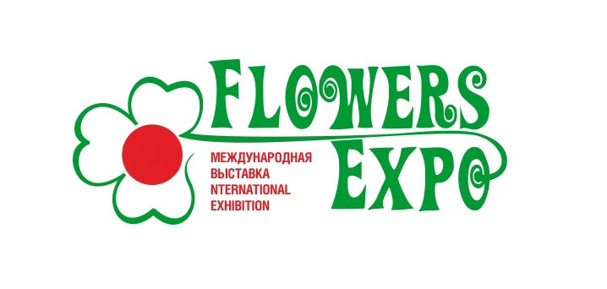
XV International exhibition «FlowersExpo 2025»
Exhibition and Forum "Green Expo. Life in Eco Style"
Moscow, International exhibition center «Crocus Expo»
Pavilion 1, halls 1,3,4 8 -10 September 2025
E-mail: ez@flowers-expo.ru www.flowers-expo.ru
_____________________________________________________________________________________________________________

Competition "For the best innovative solution in the field of engineering,
technological and material support for the production and sale of flowers"

This competition is organized within the framework of the International Exhibition "FlowersExpo" with the aim of identifying and quickly introducing innovative engineering and agricultural solutions into production, encouraging creative initiatives of developers and companies actively involved in introducing developments into production.

1. The main objective of the competition:
assistance in the rapid introduction of the latest resource-saving engineering and scientific developments in the field of flower production and sales in Russia, ensuring maximum output with minimal energy, material and labor costs.
2. Organizers of the competition: Organizing Committee of the exhibition "FlowersExpo"
3. Participants of the competition:
Russian and foreign enterprises and organizations involved in the construction and operation of greenhouse complexes, the production of engineering equipment for them, the development and production of new materials, as well as the development of technological equipment and technology for the production and sale of flower crops.
4. Conditions of participation in the competition:
Participants of the competition submit applications for participation in the competition in nominations:
Section "Production of structures, technological equipment and materials":
□ Cultivation structure
□ Alternative energy
□ New developments in engineering and technological systems, equipment and materials for the production and sale of flowers
Section "Implementation and Operation":
□ Best Innovative Project of the Year for Flower Production
□ Innovative domestic and foreign technologies and equipment for floriculture
The following documents must be attached to the application:
- Brief description of the exhibit + photo, and, if possible, drawings and calculations.
- Brief description of advantages over existing models
- Information required during the assessment: price, economic feasibility, rationalization effect, energy saving, positive impact on the environment, etc.
The application specifies the technical characteristics and advantages of the object submitted for the competition.
Mandatory condition of the competition:
The project, equipment, and materials submitted for the competition must be presented at the “FlowersExpo” exhibition.
The participant bears sole responsibility for the legal purity and correctness of the materials submitted.
By applying to participate in the competition, the participant thereby gives the competition organizers the right to publish information about the presented development in the open press (exhibition catalog, press release, etc.)
5. Application deadline: no later than August 20, 2025.
6. The work of the competition jury: September 8 from 10.00 to 12.00
7. Competition awards:
best in the nomination: awarded - Diploma and Medal of the Laureate of the Exhibition.
8. The winners of the competition are awarded based on the results of the jury.
9. The awards ceremony will take place during the “FlowersExpo 2025” exhibition.

Organizing Committee of “FlowersExpo” exhibition

