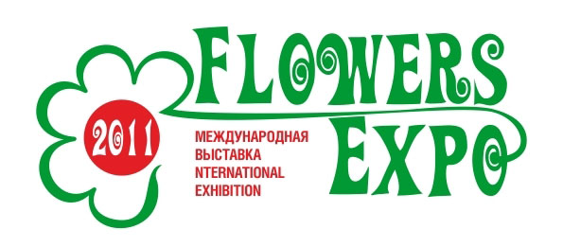
The International Exhibition «FlowersExpo Russia»

Moscow, International exhibition centre «Crocus Expo»
Pavilion 13, August 30 – September 2, 2011

Application for press accreditation

- The accreditation is free of charge.
- Using and coping of the materials of the exhibition’s press-centre is allowed only if will be the indication that the info was from the official web-site: http://www.flowers-expo.ru

The name of the company_____________________________________________
Address ___________________________________________________________
Phone (with area code):
Fax (with area code):_________________________________________________
E-mail: ____________________________________________________________
Names
Position:

Date « » 2011

Signature:

Press-centre of the exhibition:
Phone : + 7 (495) 221-12-51
E-mail: ez@flowers-expo.ru , mail@flowers-expo.ru

